**Java SortedMap Interface**

The SortedMap interface of the Java collections framework provides sorting of keys stored in a map.

It extends the Map interface.

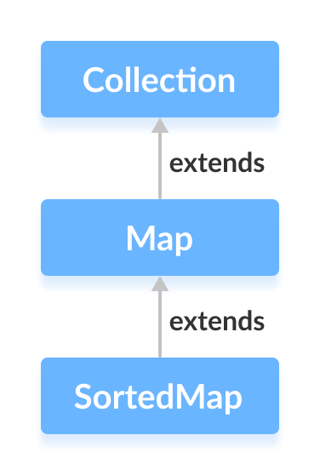

## Class that implements SortedMap

Since NavigableMap is an interface, we cannot create objects from it.

In order to use the functionalities of the SortedMap interface, we need to use the class TreeMap that implements it.

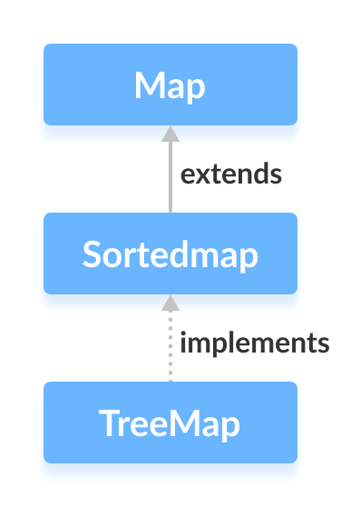

## How to use SortedMap?

To use the SortedMap, we must import the java.util.SortedMap package first. Once we import the package, here's how we can create a sorted map.

// SortedMap implementation by TreeMap class

SortedMap<Key, Value> numbers = new TreeMap<>();

We have created a sorted map called numbers using the TreeMap class.

Here,

* Key - a unique identifier used to associate each element (value) in a map
* Value - elements associated by keys in a map

Here, we have used no arguments to create a sorted map. Hence the map will be sorted naturally (ascending order).

## Methods of SortedMap

The SortedMap interface includes all the methods of the Map interface. It is because Map is a superinterface of SortedMap.

Besides all those methods, here are the methods specific to the SortedMap interface.

* **comparator()** - returns a comparator that can be used to order keys in a map
* **firstKey()** - returns the first key of the sorted map
* **lastKey()** - returns the last key of the sorted map
* **headMap(key)** - returns all the entries of a map whose keys are less than the specified key
* **tailMap(key)** - returns all the entries of a map whose keys are greater than or equal to the specified key
* **subMap(key1, key2)** - returns all the entries of a map whose keys lies in between key1 and key2 including key1

To learn more, visit Java SortedMap official documentation.

## Implementation of SortedMap in TreeMap Class

import java.util.SortedMap;

import java.util.TreeMap;

class Main {

public static void main(String[] args) {

// Creating SortedMap using TreeMap

SortedMap<String, Integer> numbers = new TreeMap<>();

// Insert elements to map

numbers.put("Two", 2);

numbers.put("One", 1);

System.out.println("SortedMap: " + numbers);

// Access the first key of the map

System.out.println("First Key: " + numbers.firstKey());

// Access the last key of the map

System.out.println("Last Key: " + numbers.lastKey());

// Remove elements from the map

int value = numbers.remove("One");

System.out.println("Removed Value: " + value);

}

}

**Output**

SortedMap: {One=1, Two=2}

First Key: One

Last Key: Two

Removed Value: 1

To learn more about TreeMap, visit Java TreeMap.

Now that we know about the SortedMap interface, we will learn about its implementation using the TreeMap class.